3. Summary
TravelNotes is a personal travel-tracking app. It allows users to make notes about visited cities and places, and probably rate them. It holds a hierarchy of “Countries → Cities → Places”, each marked as “Visited” or “Planned”, and lets the user attach their own notes and reviews to any level of that hierarchy. The list of countries, cities is pre-defined before the user input and stored in the database. The places and notes are created by the user and saved into the database.

Each place has 4 data points: name, status, map coordinates (google maps api) and a category (landmark, museum, cafe, etc.). A user note is a text entry (title, rating, date visited, free text) attached to a place

4. Introduction
TravelNotes consist of 3 pages:
- Register
- Login
- Dashboard. That's the main data page.

Progress been made:
- Created barebones Express MVC skeleton in app_server/ with routes, controllers, and views folders
- Created three static pages (Register, Login, Dashboard) each rendering a page-specific title via res.render()
- Added styles using Bootstrap elements. Shared elements (footer) in layout.pug, login and register cards for corresponding pages.
- Added dummy (hardcoded) data for each page

GitHub repository:
https://github.com/Danil-Kramnov/travelnotes
Render URL:
xxx

5. Views
Three Pug views currently exist, all extending a shared layout:
- app_server/views/layout.pug – shared head/body + footer block.
- app_server/views/register.pug – Register page + registration card.
- app_server/views/login.pug – Login page + login card.
- app_server/views/dashboard.pug – Dashboard with dummy data.

layout.pug
doctype html
html
head
meta(name='viewport', content='width=device-width, initial-scale=1.0')
title= title
//- Footer design from https://bootsnipp.com/snippets/lGEO2
link(rel='stylesheet', href='https://maxcdn.bootstrapcdn.com/bootstrap/4.1.1/css/bootstrap.min.css')
link(rel='stylesheet', href='/stylesheets/style.css')

//- All html to pug conversion done by this: https://html-to-pug.com/
body.d-flex.flex-column.min-vh-100
block navbar

main.flex-grow-1
block content

footer.bottom.section-padding.bg-dark
.container
.row
.col-md-12.text-center
.copyright
p © #{new Date().getFullYear()} TravelNotes — All rights reserved.

script(src='https://cdnjs.cloudflare.com/ajax/libs/jquery/3.2.1/jquery.min.js')
script(src='https://maxcdn.bootstrapcdn.com/bootstrap/4.1.1/js/bootstrap.min.js')

layout .pug contains shared footer and styles across all pages

register.pug (login.pug follow the same pattern)
extends layout
block content
//- Register card from: https://bootsnipp.com/snippets/z8l2X
.container
.row
.col-md-5.mx-auto
.myform
.logo.mb-3
.col-md-12.text-center
h1 Sign up
form(action='/register', method='POST', name='registration')
.form-group
label(for='name') Name
input#name.form-control(type='text', name='name', value=user.name, placeholder='Enter your name')
.form-group
label(for='email') Email address
input#email.form-control(type='email', name='email', value=user.email, placeholder='Enter email')
.form-group
label(for='password') Password
input#password.form-control(type='password', name='password', placeholder='Enter password')
.form-group
label(for='confirmPassword') Confirm password
input#confirmPassword.form-control(type='password', name='confirmPassword', placeholder='Confirm password')
.col-md-12.text-center.mb-3
button.btn.btn-block.mybtn.btn-primary.tx-tfm(type='submit') Register
.form-group
p.text-center
a(href='/login') Already have an account?
Each page renders its own title, user.name and user.email passed in from its controller via res.render()

Dashboard.pug
extends layout
//- Bootstrap components used: navbar, card, list-group, badge, form-row grid (https://getbootstrap.com/docs/4.1/components/navbar/#how-it-works)
block navbar
nav.navbar.navbar-expand-lg.navbar-dark.bg-dark
a.navbar-brand(href='/dashboard') TravelNotes
button.navbar-toggler(type='button', data-toggle='collapse', data-target='#navbarContent', aria-controls='navbarContent', aria-expanded='false', aria-label='Toggle navigation')
span.navbar-toggler-icon
#navbarContent.collapse.navbar-collapse.justify-content-end
span.navbar-text.text-white.mr-3 Hi, Daniel
a.btn.btn-outline-light.btn-sm(href='/login') Logout

block content
//- Card visual styling: https://bootsnipp.com/snippets/67z63

.container.mt-4
h2.mb-3 My Destinations

each country in countries
.card.mb-3
.card-header
strong= country.name
.card-body
each city in country.cities
h5.mt-2= city.name
ul.list-group.mb-3
each place in city.places
li.list-group-item.d-flex.flex-column.flex-sm-row.justify-content-between.align-items-start
div
div
strong= place.name
small.text-muted= ' · ' + place.category
if place.note
div.text-muted= place.note
else
div.text-muted.font-italic no note yet
span.badge(class=place.status === 'Visited' ? 'badge-primary' : 'badge-warning')= place.status

.card.mt-4
.card-body
h5.card-title Add a note
form(action='/notes', method='POST')
.form-row
.form-group.col-md-6
label(for='noteTitle') Title
input#noteTitle.form-control(type='text', name='title', placeholder='Title')
.form-group.col-md-6
label(for='noteRating') Rating (1–5)
input#noteRating.form-control(type='number', name='rating', min='1', max='5', placeholder='e.g. 4')
.form-group
label(for='noteText') Notes
textarea#noteText.form-control(name='text', rows='3', placeholder='Write your note...')
button.btn.btn-success(type='submit') Save note
Dashboard page contains navbar, row-grid, list-group from bootstrap docs. For the main card I’ve used another custom bootsnip element (referenced in the code)

UI framework (Bootstrap)
On all my pages I’ve been using custom bootsnip cards which I referenced throughout the code. And for dashboard I used some atomic elements from bootstrap 4.1 documentation (also referenced)

Data binding
Each controller builds a plain JavaScript object:
const countries = [
{
name: 'Ireland',
cities: [
{
name: 'Tralee',
places: [
{
name: 'Blennerville Windmill',
category: 'Landmark',
status: 'Visited',
note: 'Great little museum, windy day',
},
…
and passes it as the second argument to res.render(), which the corresponding Pug view then reads:
res.render('dashboard', { title: 'Dashboard', countries });
The view consumes it with Pug's each loop and attribute interpolation:
each country in countries
.card.mb-3
.card-header
strong= country.name
At this stage the data (countries array, user object for login/register) is hardcoded inside the controller

Responsive design

12-column grid used for layout structure in a few places:

footer.bottom.section-padding.bg-dark

.container

.row

.col-md-12.text-center

The login/register forms center a card using an offset-style grid:

.container
.row
.col-md-5.mx-auto
.myform
.logo.mb-3
.col-md-12.text-center
h1 Sign up
This is full-width (12 columns) below the md breakpoint, then narrows to 5 columns and centers itself once the viewport is wide enough. The dashboard's note-entry form places two fields side by side on larger screens using form-row.
Each field takes 6 of 12 columns (half-width) at md and above, stacking to full width below it.
.form-group.col-md-6
label(for='noteTitle') Title
input#noteTitle.form-control(type='text', name='title', placeholder='Title')
.form-group.col-md-6
label(for='noteRating') Rating (1–5)
navbar-toggler hides the nav links behind a hamburger button below the lg:
button.navbar-toggler(type='button', data-toggle='collapse', data-target='#navbarContent', aria-controls='navbarContent', aria-expanded='false', aria-label='Toggle navigation')
span.navbar-toggler-icon

6. Controllers
One controller per page, each exporting an index function used by the matching route:

app_server/controllers/registerController.js
const index = function (req, res) {
const user = {
name: 'test',
email: 'test@example.com',
};

res.render('register', { title: 'Register', user });
};
module.exports = { index, };
loginController.js and registerController.js follow the same shape, rendering 'login' and 'registration' respectively.

app_server/controllers/dashboardController.js
dashboardController.js contains dummy data
const index = function (req, res) {
const countries = [
{
name: 'Ireland',
cities: [
{
name: 'Tralee',
places: [
{
name: 'Blennerville Windmill',
category: 'Landmark',
status: 'Visited',
note: 'Great little museum, windy day',
},
{
name: 'Siamsa Tíre',
category: 'Theatre',
status: 'Planned',
note: null,
},
],
},
{
name: 'Dublin',
places: [
{
name: 'Trinity College Library',
category: 'Landmark',
status: 'Planned',
note: null,
},
{
name: 'Guinness Storehouse',
category: 'Museum',
status: 'Visited',
note: 'Busy but worth it for the rooftop view',
},
],
},
],
},
];

res.render('dashboard', { title: 'Dashboard', countries });
};

module.exports = { index, };

Data structure in the controller
xxx

7. Routes
app_server/routes/index.js maps each URL to its controller:
const express = require('express');
const router = express.Router();
const ctrlRegister = require('../controllers/registerController');
const ctrlLogin = require('../controllers/loginController');
const ctrlDashboard = require('../controllers/dashboardController');

router.get('/register', ctrlRegister.index);
router.get('/login', ctrlLogin.index);
router.get('/dashboard', ctrlDashboard.index);
router.get('/', (req, res) => res.redirect('/login'));

router.post('/login', (req, res) => res.redirect('/dashboard'));
router.post('/register', (req, res) => res.redirect('/dashboard'));

module.exports = router;
'/' currently redirects straight to '/login' or to /dashboard after valid login/registration with dummy data
xxx Do I need to update this section later after I have the data wired up?

8. Model
coords - variables for latitude and longitude (lat/lng)
Schema validation: for the status I’ve used enum, so only "Visited" or "Planned" can be saved.
- Mongoose sits between Express and MongoDB
- Cities, places and notes are embedded as subdocuments
- Validation lives in the schema: required, enum on status, and min/max on rating and the coordinates.
- Coordinates are stored as plain lat/lng
- The connection string lives in .env (ignored in git)

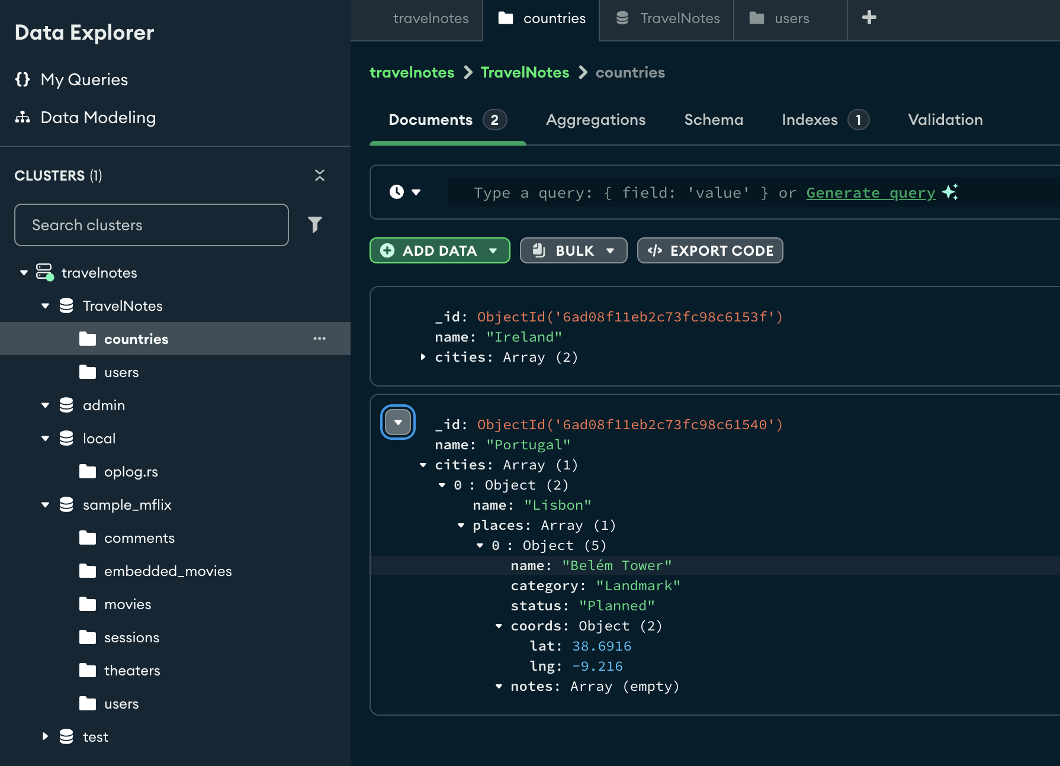
Some text
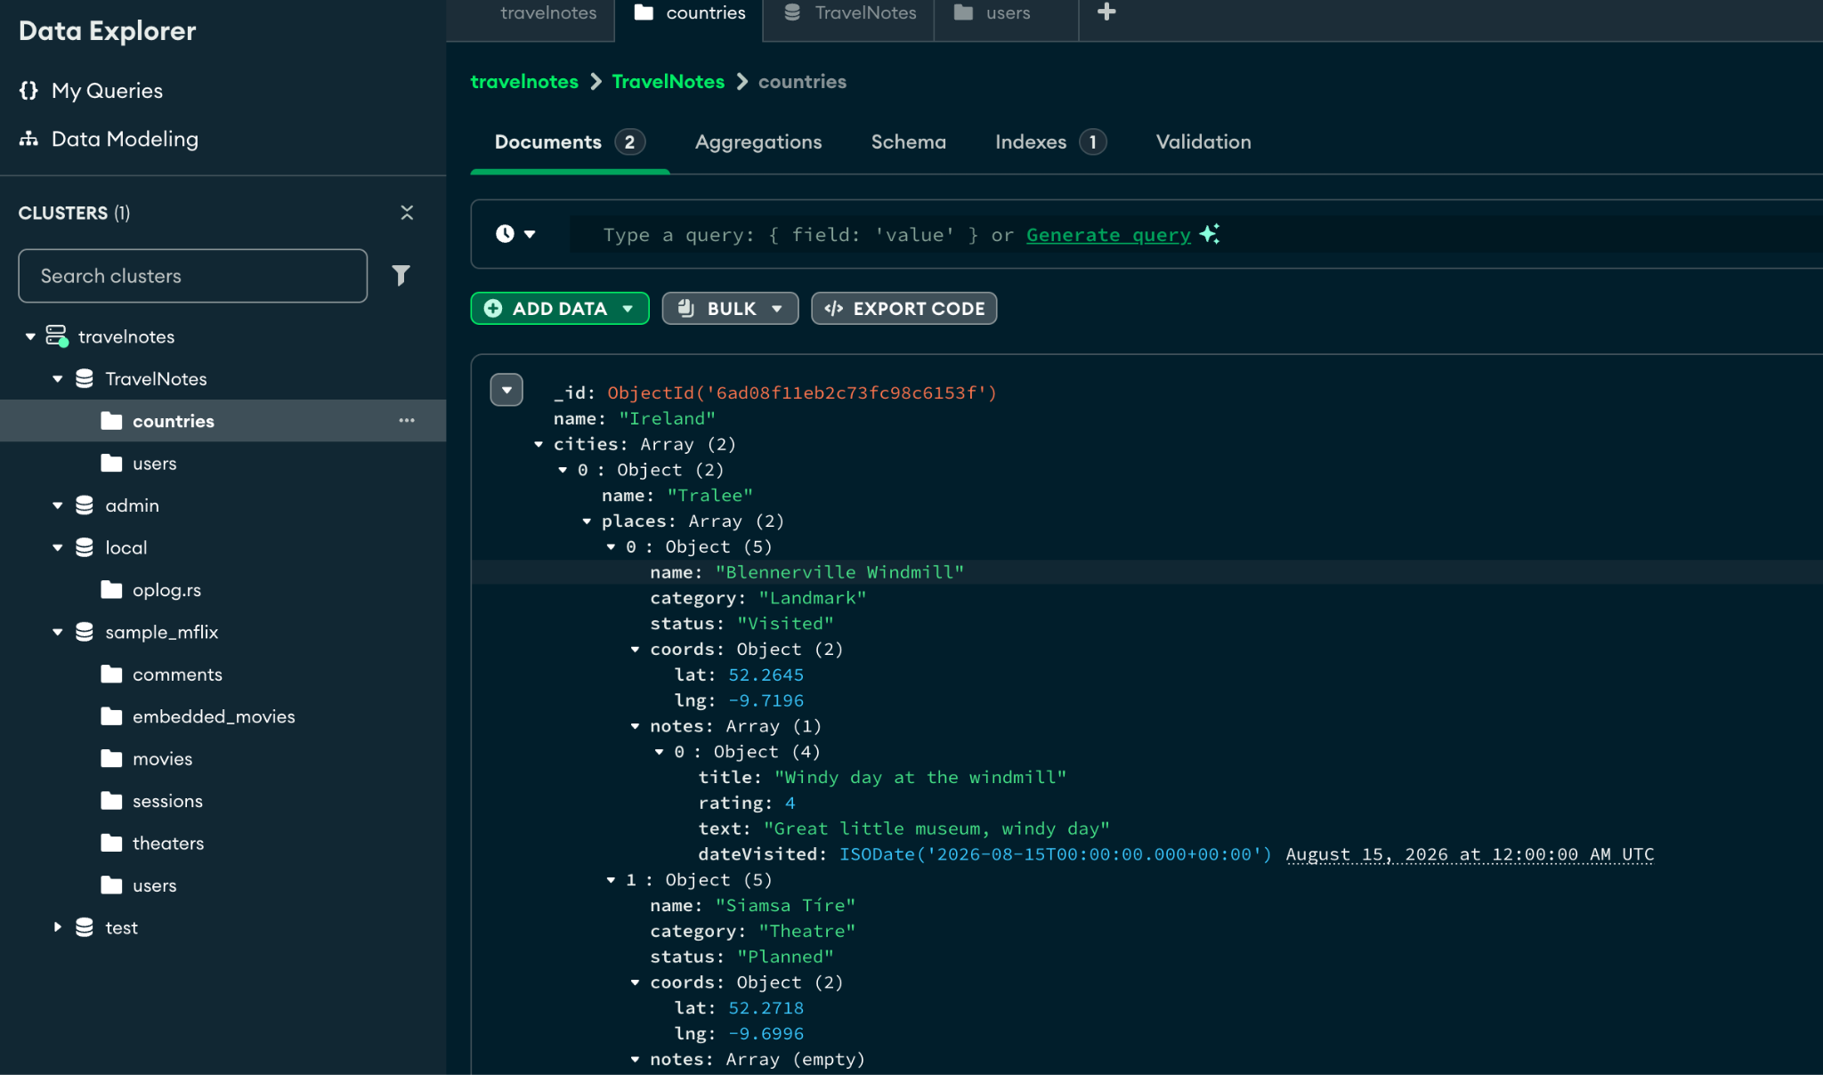
Some text
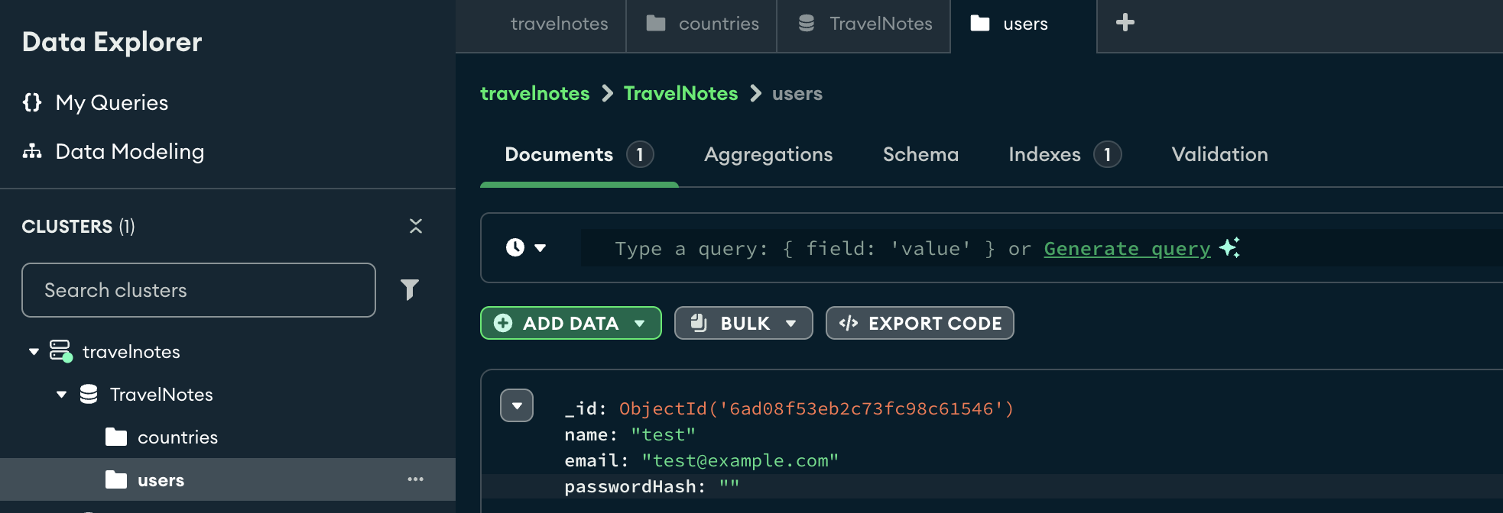

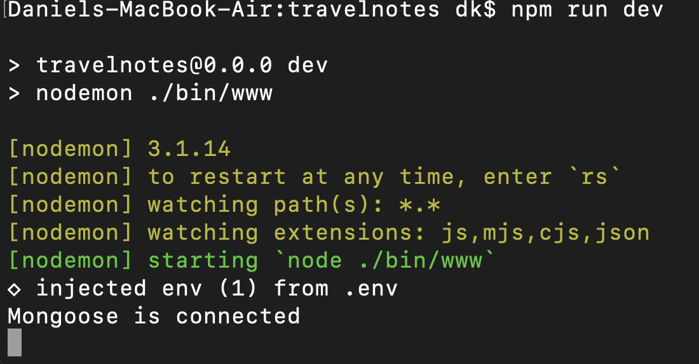
Sample text
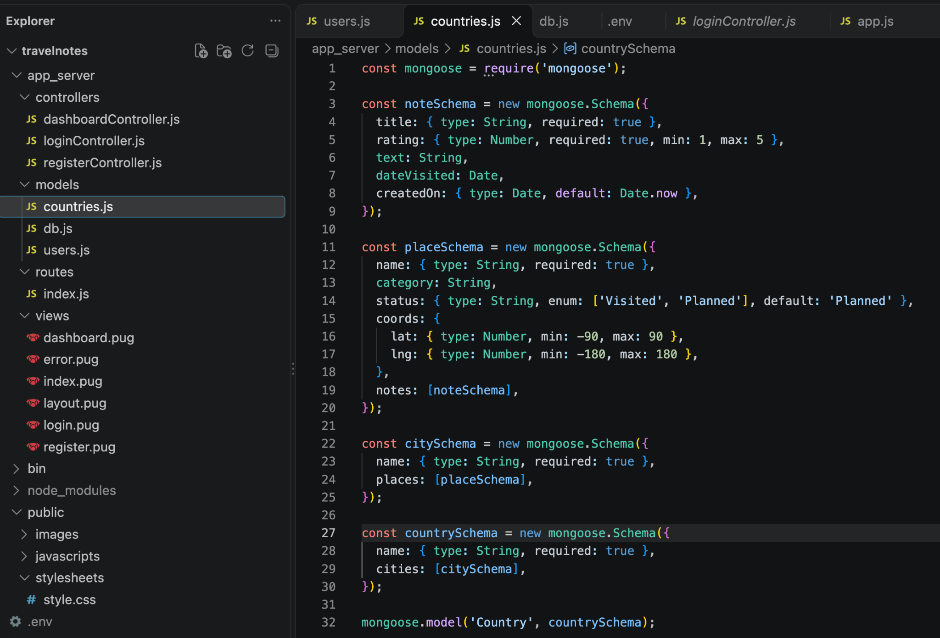
Sample text
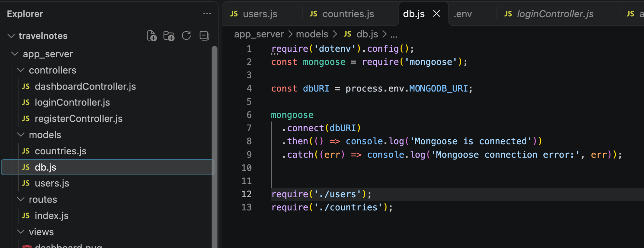
sample text
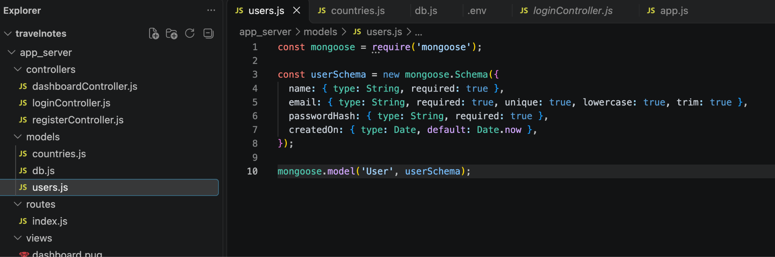
Sample text

